Field of View and Measuring things Under the Microscope

The objects under a microscope are too small to use mm so the unit Um is used.
mm | Um
1 | 1000
2
 | 200
 | 2500
0.75
1.4
0.02

Field of View: is the diameter of the circle of light that you see when looking into a microscope.
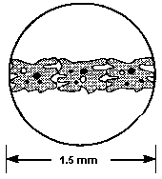
1500Um
If we know the field of view and how many cells it takes to reach from one side of the field of view to the other we can estimate the size of one cell.
In the diagram above it takes 3 cells to reach from one side of the field of view to the other. So each cell = 1500Um – 3 = 500Um
How big is this cell below in Um?
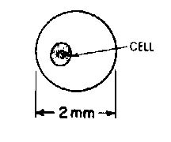
As the power gets greater, the field of view gets smaller.
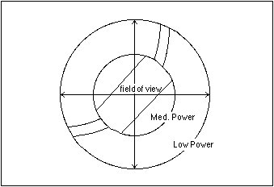

Typically you will see:

Ocular lens magnification | Objective lens magnification | Total magnification | Field of view (Um)
X10 | X4 | X40 | 4500
X10 | X10 | X100 | 1800
X10 | X40 | X400 | 450
X10 | X100 | X1000 | 180

Which of the two pictures show the field of view at highest magnification?


The total magnification is x100 for the picture of the cell on the left. Measuring from the two furthest apart ends of the cell (longways) how big is the cell?
Drawing what You See Under the Microscope
-use pencil
-don’t shade
-take space
-give a heading
-underline the heading
-show magnification (ocular, objective and total).
-label any organelles that you can recognise.

Here is an example

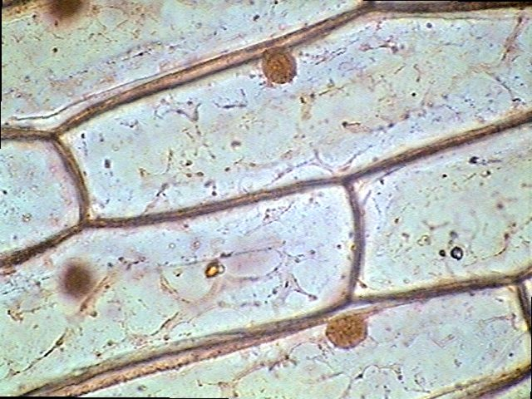

Onion Skin Cell

Cell wall
Cell membrane
Cytoplasm

Nucleus

Magnification
Ocular x10
Objective lens x10
Total x100

Try this one. It show 3 human cheek cells. They are being viewed with an ocular lens at x10 and an objective lens at x40.


